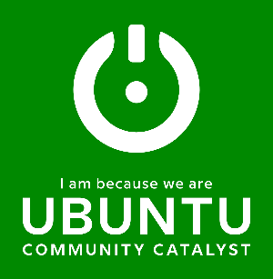
Development Coordinator Internship (Paid)

Ubuntu Community Catalyst is currently seeking a Part-time Development Coordinator Intern to join our team.

Ubuntu Community Catalyst is a neighborhood development platform. By working with stakeholders within a community, we facilitate community members to identify systemic issues and create a plan to dismantle them. We build community resilience with compassion and determination. Our current initiative is the LiveWell South Fulton Collective. Community stakeholders have identified the most pressing issues within the South Fulton County neighborhoods.

- Behavior/Mental Health
- Early Childhood Education
- Economic/Workforce Development
- Environmental Health/Justice
- Housing Affordability

Key Responsibilities:
- Plan, organize, and draft the agenda for the October 2023 Ubuntu Awards Luncheon
- Create a marketing campaign to generate awareness and funding support for the Ubuntu Awards Luncheon
- Identify and secure donors/funders for the Ubuntu Awards Luncheon
- Promote the event across various social media channels
Qualifications:
- Prior event planning experience
- Experience in marketing/communications, public relations, creative writing, or related field
- Excellent attention to detail and strong interpersonal skills
- Proficient in various software platforms, including Microsoft Office, Facebook, Twitter, Instagram, and YouTube
- Graphic design experience and proficiency in Adobe Photoshop, Canva, Publisher, and other comparable software
- Passion for our mission and commitment to servant leadership
Benefits:
- Gain insight into and support a people-centered initiative creating solutions to address pressing social issues
- Part-time remote position 10 hours per week
- Expand your network connections

This internship is a collaboration with the Institute for Leadership and Social Impact (ILSI) at Georgia Tech. The student selected for this position will receive a Social Impact Fellowship from ILSI in the amount of $1,500 which will be paid over the 10 weeks of the internship. Students are expected to work 10 hours a week on average. Students need to be eligible for campus employment. ILSI will handle onboarding and biweekly payments and Fellows are expected to complete a blog post about their internship experience and participate in one Fellowship event with ILSI.
Please submit a resume, letter of interest (in Word or PDF), and a writing sample addressed to Mary Wilson, [mary@ubuntucc.net] with the subject line “Development Coordinator Intern.”

