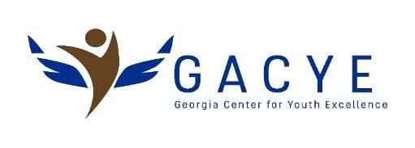

Position: Social Media Intern
Working Hours: 10 hours per week (flexible) for 10 weeks
Location: Virtual: (with some in-person as necessary)
Website: www.gacye.org
How to Apply: Please email your CVs to mike@gacye.org

Organization Background: Established in 2016, the Georgia Center for Youth Excellence is an organization whose goals are to:
- Provide a multitude of programs and services in a safe environment that will contribute to their asset-building development
- Enhance leadership development among the youth
- Serve as a community-based organization that is an extension to the learning provided in their educational development
- Provide multicultural bridge-building services for immigrants, refugees, and other youth that have migrated to the United States for better opportunities.
- Provide supportive services for youth that are victims of homelessness, sexual exploitation, drug or alcohol abuse, or any other abuse that prevents them from becoming productive citizens in their communities.
Position Summary

Social media interns work under the supervision of the Executive Director to create social media posts, assist in fundraising campaigns, increase the number of followers, maintain the accuracy of posting content, keep social media accounts updated, and analyze analytics of posts.
Duties And Responsibilities
- Work alongside the staff to create a plan for social media strategies monthly
- Assist in the growth of the brand by raising awareness through various social media platforms
- Monitor postings to ensure the brand message is constant from the terminology used to images posted
- Assist with promoting the organization’s fundraising campaigns through various social media platforms
- Interact with followers and potential customers by communicating and answering questions through the company's social pages
- Assist in implementing plans to increase followers on popular social media websites such as Twitter, Facebook, YouTube, Alignable, and LinkedIn

Minimum Requirement
- 1-2 years of social media management experience
- Familiar with multi-social posting through programs
- Comfortable with working with Microsoft Office and Adobe Suites
- General knowledge of Search Engine Optimization and internet ranking for web content
- Entry-level experience determining how to cater unique marketing campaigns to a unique audience
- Ability to work alongside a diverse group of employees
- Entry-level understanding of marketing strategy and how to use the concepts throughout various forms of outreach

"This internship is a collaboration with the Institute for Leadership and Social Impact (ILSI) at Georgia Tech. The student selected for this position will receive a Social Impact Fellowship from ILSI in the amount of $1,500 which will be paid over the 10 weeks of the internship. Students are expected to work 10 hours a week on average. Students need to be eligible for campus employment. ILSI will handle onboarding and biweekly payments, and Fellows are expected to complete a blog post about their internship experience and participate in one Fellowship event with ILSI"

